Friends: because of my duties with the Columbia International Festival, I don’t have time to tweak the lessons for the next three weeks. We will use these, as created by Kathy. You can adjust to your level (upper, middle or lower). ~Michael

May 28 2021~ Using American Slang, #4 (Set 2, Lesson 12)
American Slang: [sth = something; sb = somebody]

1. pull an all-nighter = work or study all night Our team pulled an all-nighter in order to finish the project.

2. around-the-clock = 24/7; all day & night; non-stop Their house alarm system gives around-the-clock protection.

3. a ballpark figure of sth for sth/sb = an estimated amount of time or money needed for sth/sb
I need a ballpark figure of the final cost for the equipment we need to order.

4. that’s behind me ; I’ve put it behind me = It’s in the past, and it doesn’t matter to me anymore. I used to feel depressed about my divorce, but that’s behind me now. I failed the GRE, but I’ve put it behind me and will try again.

5. sth/sb blows sb away = really impress or amaze sb
sb is blown away by sth/sb = sb is really impressed or amazed by sth/sb
Her dance performance blew us away. We were blown away by her dance performance.

6. blow sth out of proportion = make sth seem much more important than it actually is He had no reason to be so angry about my mistake. He always blows things out of proportion!

7. bosses (v) sb around = constantly tells sb what to do Her older brother likes to boss her around.
sb is bossy (adj) = sb likes to tell other people what to do He is bossy with his younger sister.

8. sb is/feels bummed (out) = sb is/feels really disappointed He was really bummed (out) about losing the game.

9. it (really) burns me up = it really upsets me; it makes me angry; I feel angry
It really burns him up when she talks to him with that tone of voice.

-----------------------------------------------------------------------------------------------------------------------------------------------------------------

Questions: (Use the underlined phrase when you answer a question, to make sure you can use it correctly.)

1. Share about one time when you pulled an all-nighter. What was the result? Was it worth it? Why or why not?

2. In what kind of situation would you need or want around-the-clock service/help/protection? Give a specific example.

4. If you don’t mind, please share about a past failure that is now behind you (= not important to you now). How did you put it behind you?

5. Share about one time when something blew you away: something you saw, or somebody’s gift to you, or somebody’s kindness to you, or something else. (Sth/Sb blew me away when …. or I was blown away by sth/sb when ….)

6. Share about one time when somebody made a small mistake, and somebody else blew it out of proportion.

7. When you were growing up, did anyone (besides your parents) sometimes boss you around? If so, who? How did you respond to that person? Also, did you boss anyone around? If so, who? How did that person respond to you?

8+9. Share about one time when you were bummed (you were bummed out) about something, or when something happened that burned you up. How did you deal with that situation?

___________________________________________________________________________________________________________

June 4 2021~ Different Perspectives (Set 2, Lesson 13)

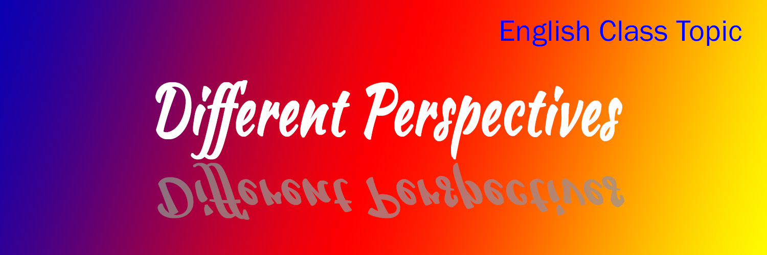
Phrases in the story: [sth = something; sb = somebody]

sb is in and out of sth = sb has an experience off and on Samuel was in and out of trouble throughout high school.
sb is with sb = (1) sb supports sb emotionally; (2) sb is physically with sb at that time
bad times = difficulties; a difficult period of time
sb supports sb = (1) sb gives sb moral support; sb supports sb emotionally; (2) sb supports sb financially
sb stands by sb = (1) sb gives sb emotional support; (2) sb stands next to sb
you are bad luck = you cause sb to have a bad experience
you have bad luck = you are unlucky; you have a bad experience

-----------------------------------------------------------------------------------------------------------------------------------------------------------------

Debbie’s husband Steve is 78 years old and has been in and out of a coma for three months. She has stayed by his side day after day, taking care of him. One day he opened his eyes and saw her smiling warmly at him. He began to speak to Debbie: “You’ve been with me through so many bad times. When I broke my leg in college playing football, you rode in the ambulance with me to the hospital. After we got married, I couldn’t find a job for a long time, and you were there to support me. When that big truck hit us on the highway, you were in the car with me. When we lost our house, you stood by me while the bank sold all of our furniture in an auction. Now I’m dying, and you are still with me.” Debbie’s heart was full of love for her husband as he talked about the difficulties they had been through together. Then he said, “I think you’re bad luck.”

-----------------------------------------------------------------------------------------------------------------------------------------------------------------

Questions:

1. Sometimes people blame another person for the bad things that happen to them, even when it’s not the other person’s fault. What are 2-3 reasons people might wrongly blame another person?

2. Besides luck, what else causes the good things and the bad things that happen to you in your life? Explain.

3. Why can two people have the same bad experience and yet have a very different perspective about it? For example, two people each lost a great job, but one person thinks it’s a bad thing and the other person thinks it’s a good thing.

4. Tell a true story about one time in your life when something unexpected happened to you. It can be either a good thing or a bad thing. For example: you got a good job in spite of tough competition, you lost some money, you were in a car accident, you passed a test you thought you would fail, etc. In that good or bad situation, do you think you were lucky/unlucky, or do you think the unexpected thing happened because of another reason? Explain.

5. Tell about one person who stood by you (supported you) while you were facing a very difficult situation. How did that person show his/her support?

6. A proverb says: Every cloud has a silver lining. What does it mean? Do you agree with this proverb? Why or why not?

___________________________________________________________________________________________________________

June 11 2021~ American Values, #4: Conflicts & Choices Among 3 Main Goals (Set 2, Lesson 14)
Proverbs related to success and fun:

The end justifies the means. = You can use any method, even a dishonest method, if it helps you succeed.

Work hard, play hard. = Do your best in your job, and also fully enjoy your fun times.

If it feels good, do it. = Live according to your desires at the moment. Forget about rules or consequences. Just have fun.

You only go around once in life. = You only have one life, so enjoy it. YOLO (You only live once.)

-----------------------------------------------------------------------------------------------------------------------------------------------------------------

As previously studied, success, self-esteem, and fun are all very important in American culture, but they might not be achievable at the same time. For example, success in a career might require long working hours, so the person has no time or energy left for fun. On the other hand, if a student spends too much time having fun, he or she might flunk out of school. Success might also conflict with self-esteem. For example, in order to succeed, a person might do something dishonest, and then it’s difficult for him to respect himself. Self-esteem and fun could also conflict with each other. A fatter body can cause lower self-esteem, but dieting is not as much fun as eating.

People can choose their own definitions of success, self-esteem, and fun. For example, making lots of money might mean success to one person but not to another. Having a high position in a company might give someone self-esteem, but another person might not need a high position to have self-esteem. Swimming might be fun for one person but not fun for another.

-----------------------------------------------------------------------------------------------------------------------------------------------------------------

Questions:

1. How important are success, self-esteem, and fun to you personally? Explain the importance of each one for you.

2. In your opinion, what are the three most important values for most young adults in your country? Explain why each of those values is so important.

3. What is your own definition of success? Explain clearly, and include various areas of your life (e.g., job, family, friends, hobbies, sports, etc.)

4. What specific things need to happen so that you can respect yourself? Keep in mind various areas of your life.

5. One proverb says: “If it feels good, do it.” Share one example of when it’s wise to follow this proverb. Also, share one example of when it’s not wise to follow this proverb.

6. Besides the two examples in the article (have no time for fun because of working hard; flunk out of school because of having too much fun), share another example of when success and fun might conflict with each other. Explain.

7. Besides the example in the article (cannot respect himself because he succeeded through dishonesty), share another example of when success and self-esteem might conflict with each other. Explain.

8. Besides the example in the article (have low self-esteem because of gaining weight after enjoying too much food), share another example of when self-esteem and fun might conflict with each other. Explain.

___________________________________________________________________________________________________________
==============
These lessons were created or adapted by the staff of International Friendship Ministries, P.O. Box 12504, Columbia SC 29211; ifmusa.org; info@ifmusa.org. IFM is grateful to Kathy Williams for most of the original work. Some lessons were adapted from EFLsuccess.com (with permission). IFM makes these lessons available to our participants, but this does not imply our consent for others to publish these lessons online or in print without permission.
If posted at www.ifmusa.org/english: this resource was created for our students under the understanding of “fair use” for educational purposes.

