Oct 30 2020~ Halloween (EFLsuccess.com)

Vocabulary: **sth = something; sb = somebody.

Celtic: the Celts lived in ancient England before the time Jesus was born (0 AD/BC); today, some Celtic descendants live in Ireland, Wales and Scotland
veil: something flexible like a curtain, between two things; a thin piece of material some women wear to partially hide their faces (often for religious reasons)
spirit: related to the part of a person that lives after his/her body dies, and/or beings that exist without physical bodies (e.g., angel, devil, ghost)
ghost: the spirit of a dead person that some people think they feel or see at a certain time or place
disguise: something that changes the way you look to hide who you are, how you feel, etc.; the act of doing this
root: origin; the first thing, from which later things (customs, laws, etc) grew; the underground part of a tree/plant.
costume: a disguise or set of clothing that makes you look like someone you are not [“At the party, I saw a pirate costume, plus people dressed like ghosts and TV characters.”]
witch: a woman with the skill to manipulate supernatural powers
trunk (BrE boot): a storage place at the back of a car, where people carry suitcases, food just bought, etc.
stingy: not generous
Devil: when capitalized, the Devil is the enemy of human spirits; “devils” are fallen angels or evil spirits
heaven: God’s perfect home, where people can go after death if they are as perfect as God, or have a relationship with God
hell: a place of punishment after death for people who did not live perfect lives
lantern: something you can carry or hang that provides light
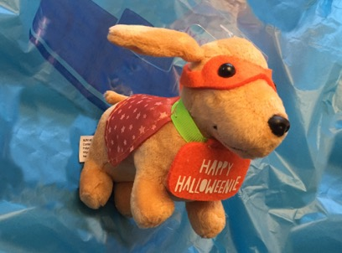
----------------------------------------------------------------------------------------------------------------------------------------------------------------

October 31 is Halloween. Historically, Halloween marked the Celtic New Year. It was believed that the veil between our world and the spirit world was thinnest, so the ghosts of dead people could walk among us. Sometimes, these ghosts would be disguised, which is the root of modern Halloween costumes. Because of its roots, Halloween decorations are often related to evil or death (ghosts, witches, the color black, etc.)
On Halloween (at least, before COVID-19), children liked to wear costumes and visit neighbors. They knocked on doors and yelled: "Trick or treat!" This earned a few pieces of candy. In recent years, parents worry about what strangers might give to children. Trusted organizations like churches and libraries sometimes offer alternative parties. For example, a church might host “Trunk or treat,” when members decorate the trunk of their car, passing out sweets to costumed visitors. Some adults like Halloween, too. You may see them wearing costumes to work, or at Halloween parties.
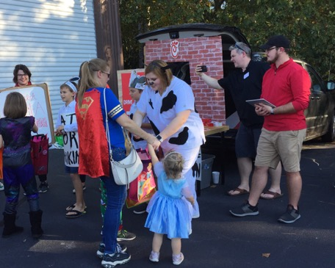
Jack-o-lanterns (carved pumpkins) are a popular decoration, and carving them is a fun family activity. As the story goes, a stingy man named Jack tricked the Devil to save his soul. After Jack’s death, both heaven and hell refused entrance, so Jack roams the earth on Halloween with a hot coal from hell to light his way. Jack carved a turnip to make a lantern for his coal, but Irish immigrants to America discovered that pumpkins make better candle-holders than turnips!
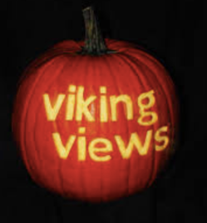
Today, though the “evil” roots of Halloween still affect decorations, many children mainly think of Halloween as a time to dress up like a favorite TV/movie character, and get lots of free candy.

--------------------------------------------------------------------------------------------------------------

Questions: (Do you want to ask the teacher about anything in the article?)

1. If a friend asked you to describe Halloween in a few words, what would you say?

2. From what you know about this holiday, what is the best or most interesting part?

3. Why do children (and even adults) like to wear costumes? If you went to a Halloween party, what kind of costume would you want to wear?

4. In your culture, is there a holiday related to death or the spirit world? If so, tell us about it. Why do many cultures have such holidays?

5. Why do you think that parents are more concerned today about what strangers might give to children, than they were a few decades ago?

6. Would you want your children to visit your neighbors on Halloween, or go to a party at a church or library? Explain.

7. Do you believe in heaven and hell? Why or why not? If you do, who do you think gets to go to heaven, and what makes you believe this? (If you wish, read and discuss Philippians 3:20-21: “But our citizenship is in heaven, and from it we await a Savior, the Lord Jesus Christ, who will transform our lowly body to be like his glorious body, by the power that enables him even to subject all things to himself.” ESV)

7. Look at these photos and the quote. Describe the photos, or talk about what the quote means.

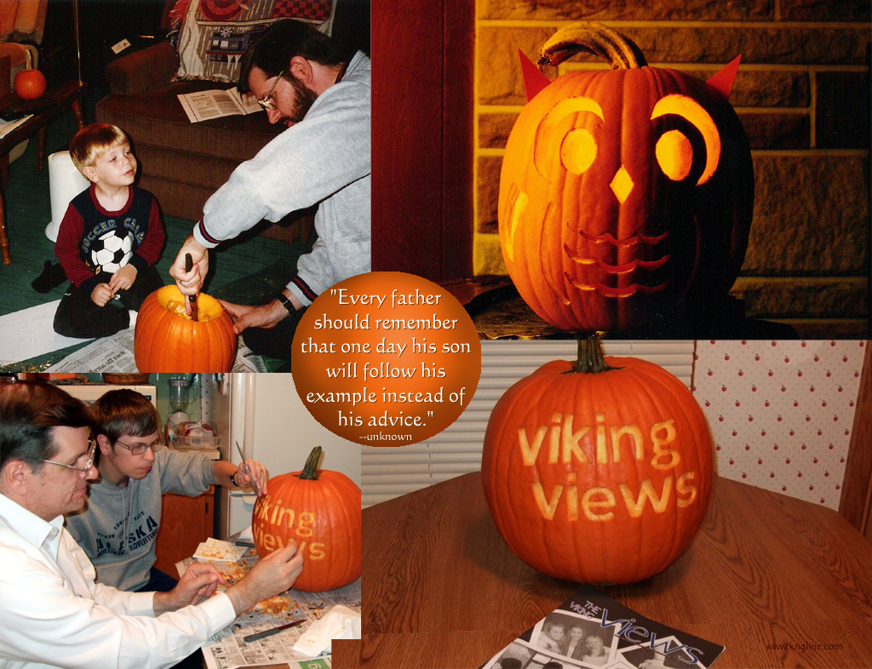
By the way, this is IFM’s Michael Krigline, with his son, many years apart. His son carved the bottom pumpkin, and used the image for his high school newsletter’s cover (“The Viking Views”).

Sources include
https://www.elcivics.com/halloween.html
https://halloween.com/2020/halloween-symbols/
https://www.livescience.com/16677-halloween-superstitions-traditions.html

=====Lower English level=====
Oct 30 2020~ Halloween (EFLsuccess.com-L)

Vocabulary: **sth = something; sb = somebody.

Celtic: the Celts lived in ancient England before the time Jesus was born (0 AD/BC); today, some Celtic descendants live in Ireland, Wales and Scotland
spirit: related to the part of a person that lives after his/her body dies, and/or beings that exist without physical bodies (e.g., angel, devil, ghost)
ghost: the spirit of a dead person that some people think they feel or see at a certain time or place
disguise: something that changes the way you look to hide who you are, how you feel, etc.; the act of doing this
root: origin; the first thing, from which later things (customs, laws, etc) grew; the underground part of a tree/plant.
costume: a disguise or set of clothing that makes you look like someone you are not [“At the party, I saw a pirate costume, plus people dressed like ghosts and TV characters.”]
trunk (BrE boot): a storage place at the back of a car, where people carry suitcases, food just bought, etc.
stingy: not generous
Devil: when capitalized, the Devil is the enemy of human spirits; “devils” are fallen angels or evil spirits
heaven: God’s perfect home, where people can go after death if they are as perfect as God, or have a relationship with God
hell: a place of punishment after death for people who did not live perfect lives
lantern: something you can carry or hang that provides light
-------------------------------------------------------
October 31 is Halloween. Historically, Halloween marked the Celtic New Year, when people believed that ghosts could walk among us. Sometimes, ghosts would be disguised, which is the root of modern Halloween costumes. Because of its roots, Halloween decorations are often related to evil or death (ghosts, the color black, etc.)
On Halloween (at least, before COVID-19), children liked to wear costumes and visit neighbors. They knocked on doors and yelled "Trick or treat!" to get a few pieces of candy. In recent years, trusted organizations like libraries sometimes offer alternative parties. For example, a church might host “Trunk or treat,” when members decorate the trunk of their car, passing out sweets to visitors. You may also see adults wearing costumes to work, or at Halloween parties.
Jack-o-lanterns (carved pumpkins) are also popular. As the story goes, a stingy man named Jack tricked the Devil. After Jack’s death, both heaven and hell refused entrance, so Jack roams the earth on Halloween with a hot coal from hell to light his way. Jack carved a pumpkin to make a lantern for his coal.
Today, Halloween is mostly a time for kids to dress up and get lots of free candy!
-------------------------------------------------------

Questions: (Do you want to ask the teacher about anything in the article? Teacher: ask the students some content questions.)

1. If a friend asked you to describe Halloween in a few words, what would you say?

2. From what you know about this holiday, what is the best or most interesting part?

3. Why do children (and even adults) like to wear costumes? If you went to a Halloween party, what kind of costume would you want to wear?

4. In your culture, is there a holiday related to death or the spirit world? If so, tell us about it. Why do many cultures have such holidays?

5. Would you want your children to visit your neighbors on Halloween, or go to a party at a church or library? Explain.

6. Do you believe in heaven and hell? Why or why not? If you do, who do you think gets to go to heaven, and what makes you believe this? (If you wish, read and discuss Philippians 3:20-21: “But our citizenship is in heaven, and from it we await a Savior, the Lord Jesus Christ, who will transform our lowly body to be like his glorious body, by the power that enables him even to subject all things to himself.” ESV)

==============
These lessons were created or adapted by the staff of International Friendship Ministries, P.O. Box 12504, Columbia SC 29211; ifmusa.org; info@ifmusa.org. IFM is grateful to Kathy Williams for most of the original work. Some lessons were adapted from EFLsuccess.com (with permission). IFM makes these lessons available to our participants, but this does not imply our consent for others to publish these lessons online or in print without permission.
If posted at www.ifmusa.org/english: this resource was created for our students under the understanding of “fair use” for educational purposes.

