Sep 2, 2022 ~ Using American Slang, #14 (Lesson c68)

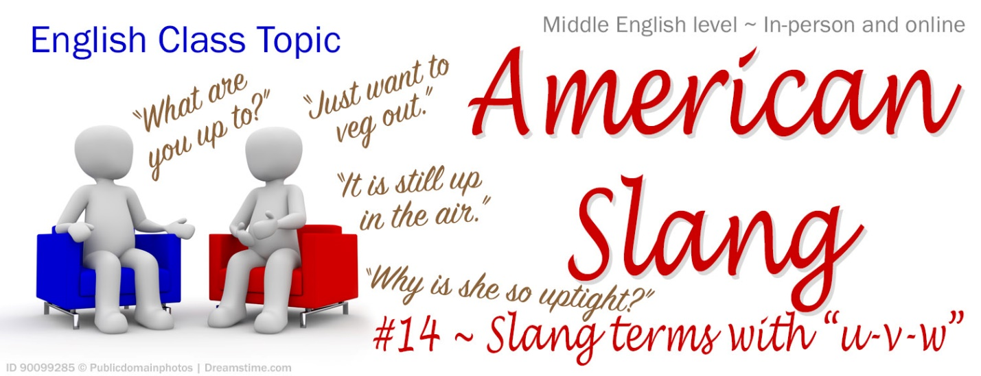
Warm up: Read the definition of “up in the air.” Ask 2-3 students to tell us one thing in his/her life right now that is up in the air. (Keep answers short; we can “explain” later!)

These definitions will help you understand a paragraph full of slang, before you discuss the questions it raises. [sth = something; sb = somebody]
- veg out = sit or lay around not thinking about any work or problem I’m going to veg out by the pool.
- What are you up to? = What are you doing? What have you been up to recently?
- to be cool = popular or well-accepted by people “Cool” is a slang term that has been cool for a long time!
- an explosion of = a sudden, powerful outburst of sth We’ve seen an explosion of technology this year.
- sb or sth vanished into thin air = disappeared (without any evidence of where he/it went or why) Has anyone heard from Robert? It seems he just vanished into thin air.
- sth is up in the air = is unresolved/undecided/uncertain The election is up in the air; anyone could win.
- sb is/gets/feels uptight = is/gets/feels very nervous; the opposite of relaxed or laid-back John always gets really uptight before job interviews.
- Uncle Sam = a nickname for the United States government One fourth of my salary goes to Uncle Sam.
- sb is up to something = is secretly planning something (either good or bad)
- have something up your sleeve = have a secret purpose/plan; be up to something secret (it can be either good or bad) I don’t trust him. I’m sure he has something up his sleeve.
- sb is up to no good = is planning to do something bad That strange smile tells me she’s up to no good.
- is anyone’s guess = anyone could be correct because it is impossible to know sth
- to rebound = basketball term meaning to catch a failed attempt to score, and try again; be resilient
- have it in hand = have it in control We’ll win this season because our coach has it in hand.
- the odds are (good) = it is likely or probable If you smoke, the odds are that it will hurt your health.

How did COVID-19 affect you? Did you often veg out in front of a TV? During lock-downs, puzzles and board games became cool again, and there’s been an explosion of educational clips on YouTube. Meanwhile, some popular events, restaurants and stores vanished into thin air. (Can you name some of them? Think about things you can’t do anymore, or special events that were canceled during Covid). For a long time, many things were up in the air (such as the ability to attend classes or weddings). Such changes made some people really uptight. Can Uncle Sam tell us to wear a mask, close our business, stop going to church, and walk a certain distance apart? Apparently, he can. Were our leaders simply trying to protect us, or do you think they were up to something? After all, politicians have a reputation for having something up their sleeve! Do you think they are up to no good? What the future will look like is anyone’s guess, but Americans are creative and tend to rebound quickly, and many have faith that God has the future in hand (have you noticed that even US money says, “In God we Trust”?). The odds are good that your life has mostly returned to normal. If so, what have you been up to in recent weeks?

Questions: (Try to use a slang term in your answers)
- How did COVID-19 affect you? Is it still affecting you? Explain.
- Do you often veg out in front of a TV or YouTube? Do you like puzzles or board games? If not, what have you been up to recently?
- Did COVID-19, and the lasting ways it changed our lives, make you feel really uptight? Explain
- Do you think that Uncle Sam is trying to protect us (with rules about masks and vaccines, etc), or do you think government leaders are up to something (up to no good)? Explain
- What is your guess about America’s future? Will people and the economy rebound? Does your faith help you during this crisis?
- Do you think that the odds are good that things will work out fine? Explain.
- Share about one thing in your life right now that is up in the air. What will help you make a final decision about it?
- Can you use these in a sentence? sb had something up your/his/her sleeve, sb is up to something, sb is probably up to no good. (in a game, late at night, at a party, at work, a classmate, etc.)

Exercise: Each student should pick one slang expression or vocabulary term from today’s lesson, and create a sentence with it. After everyone has tried, students can pick a second term.

If you have more time, read and discuss this ancient proverb: ~ “In their hearts humans plan their course, but the LORD establishes their steps.” (Proverbs 16:9 NIV)

